**Assignment 5 Snapshots – Daniel Carpenter**

**Solver Snapshot of Problem a**

* Please note that this snapshot only is shown to display the solver inputs.
* I performed executed each solver model for every person, but those models are not shown. The solver inputs reference the same cells regardless.

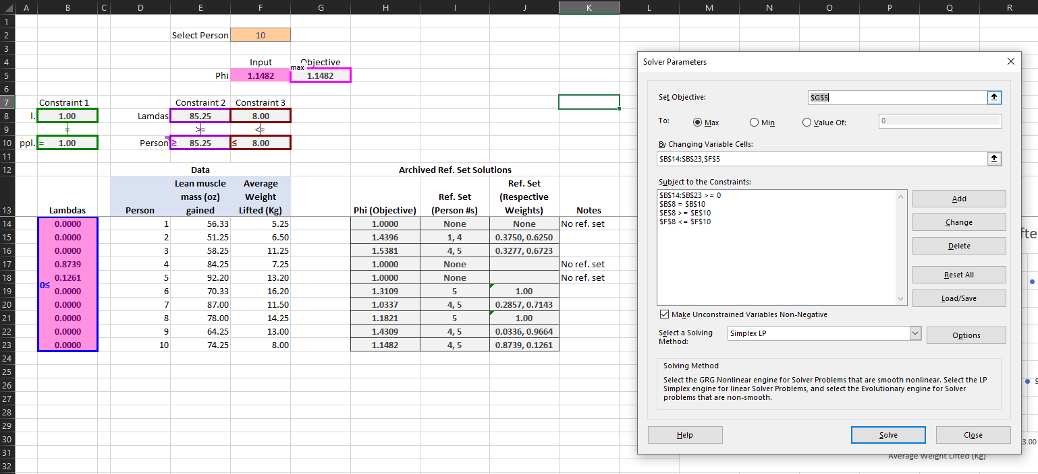

**Solver Snapshot of Problem b**

* The same notes that I gave in problem “a” apply to this screenshot.

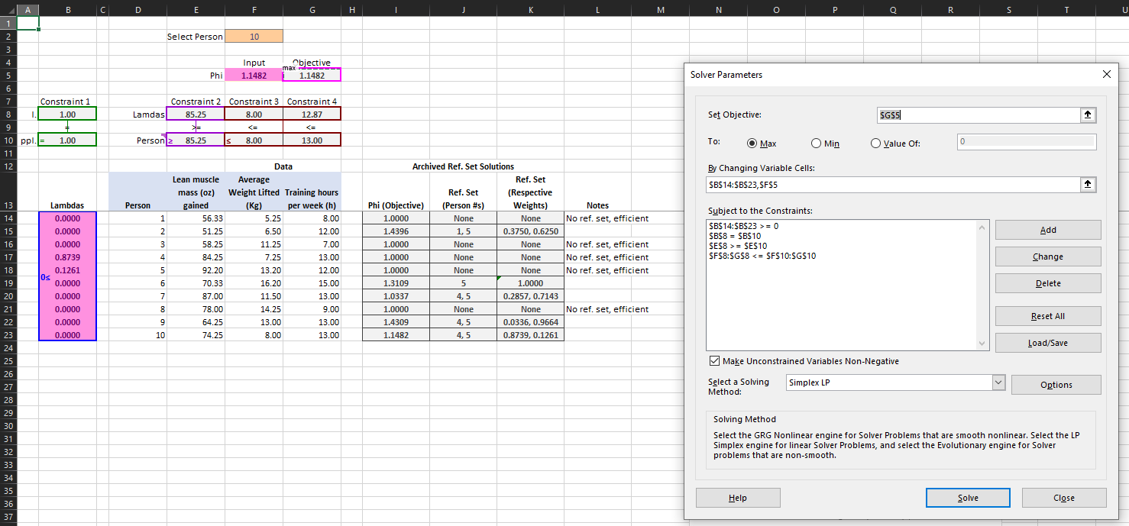

**Problem c**

**Increasing Average Weight:**

For weightlifter number 3, they would benefit from increasing the average weight lifted. For every kilogram of average weight that they increase, they will realize an increase in lean muscle mass gained of 1.5381 ounces.

Please note the following: this analysis only compares to individuals in the sample; also, this analysis only includes average weight lifted as an independent variable. When considering other factors (such as number of hours training per week), the results may change, similar to the next solution.

**Increasing Hours of Training per Week:**

For weightlifter number 3, they would not benefit from increasing the number of hours training per week. After adding both dependent variables to the model (average weight lifted, and hours trained per week), person number 3 is efficient compared to their peer group. Although they may appear efficient when only considering average weight lifted, it is not the case when including this new variable.